

PTO - Plan A Company 400, 410, 500, 600, 710

Program | Details
Program Design | - Combined Personal Leave and Holiday program (accrued bi-weekly)  - Separate Extended Illness leave time-off (accrued bi-weekly)  - Employee-paid short-term disability
Vacation/Personal Leave (PL)
Number of Days | - 29-39 days for full time employees, based on years of service, includes 11 legal holidays (part time employee accrual prorated based on hours worked)  - Accrued biweekly  - 6-month waiting period for new hires
Carryover | - Maximum of 500 hours
Annual Cash-out | - Election made December 1-21 and paid June of the year following election (12 month waiting period) with maximum of:  - 80 hours (if you have up to 10 years of service) or  - 120 hours (if you have 10 or more years of service)
Separation Payout | 100% of accrued or unused PL paid out upon separation from Jackson Health (if employed by Jackson Health for at least six months)
Holidays
Number of Days | - 11 Legal Holidays Recognized  - Included in Personal Leave  - Eligible for carryover, annual cash-out and payout upon separation
Short-term Disability/ Extended Illness
Short-Term Disability (STD) | - Voluntary, employee-paid benefit  - Benefit equals 60% of weekly pay up to a maximum of $425 (Option I) or $700 (Option II)  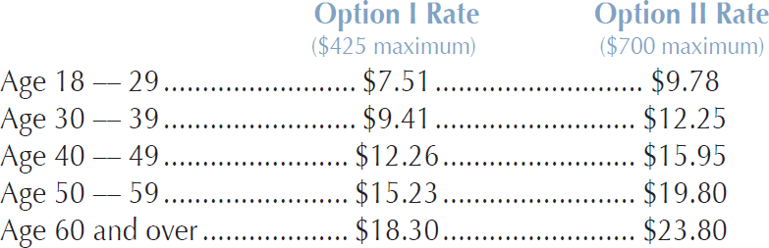
Extended Illness (EI) Accruals and Payout | - Accrual of 6 days per year; hours roll over annually with no cap  - Accrued or unused EI paid out upon separation on a prorated basis (if you have at least 10 years of service)

